Name: Tsion Yimenu
MATH 205
Final Exam
- Researchers collected samples of water from streams in the Adirondack Mountains to investigate the effects of acid rain. They measured the pH (acidity) of the water and classified the streams with respect to the kind of substrate (type of rocks over which they flow). A lower pH means the water is more acidic. Are there differences in terms of acidity between the different types of substrate (limestone, mixed, and shale)?
  - Screenshot of numerical summaries by substrate
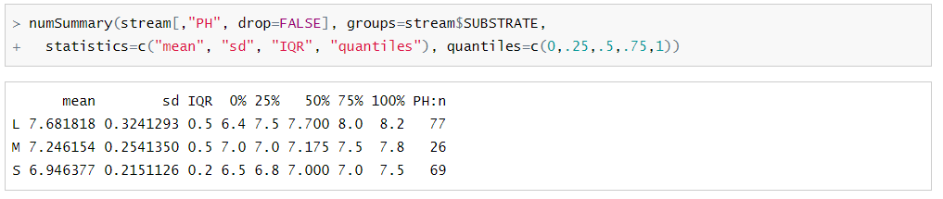
  - Screenshot of boxplots by substrate
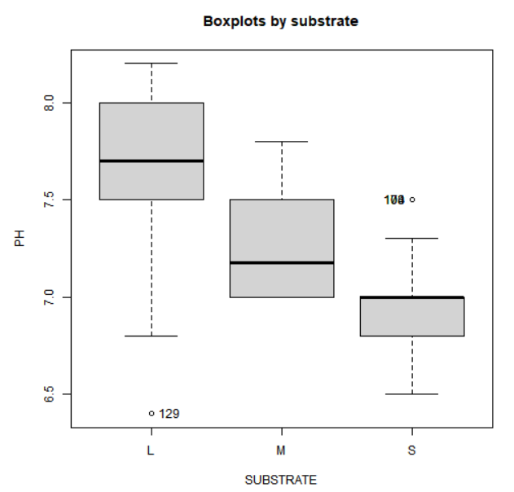
  - Null and alternative hypotheses
$$H_{0}:μ_{1}=μ_{2}=μ_{3}$$
$$H_{a}:At least two or more means are different$$

  - Appropriate test results
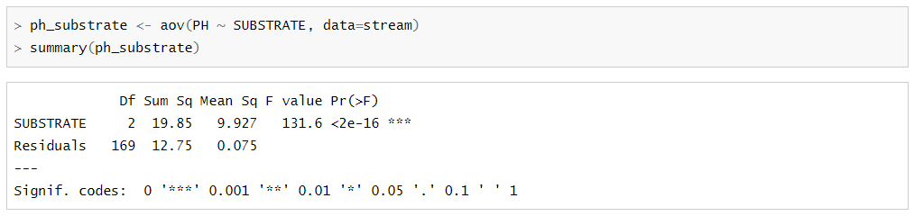
  - Check assumptions
    - Each group is normally distributed
Limestone group is approximately normal distributed. Mixed group is slightly right-skewed and finally shale group is left-skewed. Thus, this conclusion is not fully met.
    - Ratio of lowest SD and highest SD

$$\frac{0.3241}{0.2151}=1.5067$$
Because the ratio is less than 2, we conclude that the assumption of equal population variances is satisfied.
    - Independence
We have an independent simple random sample.
  - Conclusion
Because the p-value is small (i.e., less than 0.05) we reject the null hypothesis. There is enough evidence to support the claim that the mean pH is not the same for al substrate. In other words, there are differences in terms of acidity between the different types of substrate.

- A tire manufacturer tested the braking performance of one of its tire models on a test track. The company tried the tires on 10 different cars, recording the stopping distance for each car on both wet and dry pavement. Is there a difference between dry and wet pavements for this type of tire in terms of braking performance?
  - Null and alternative hypotheses
$$H_{0}:μ_{d}=0$$
$$H_{a}:μ_{d}≠0$$

  - Histogram of differences between wet and dry pavement
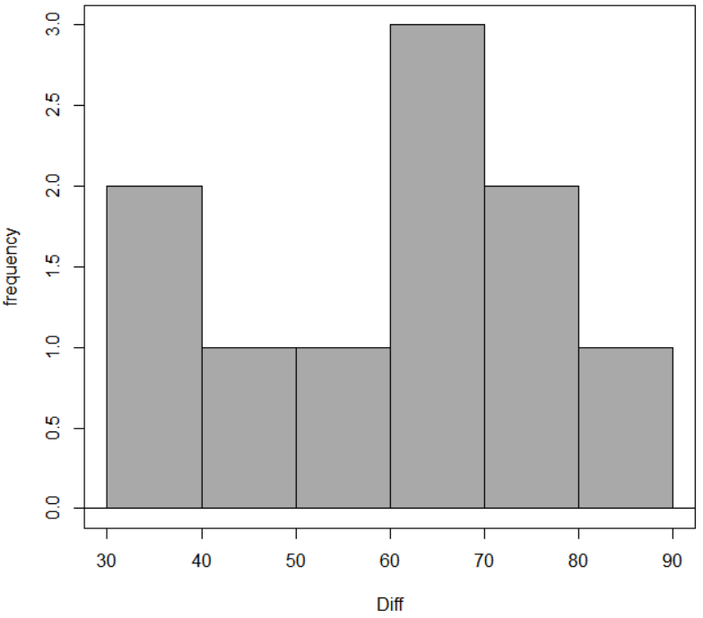
  - Appropriate test result
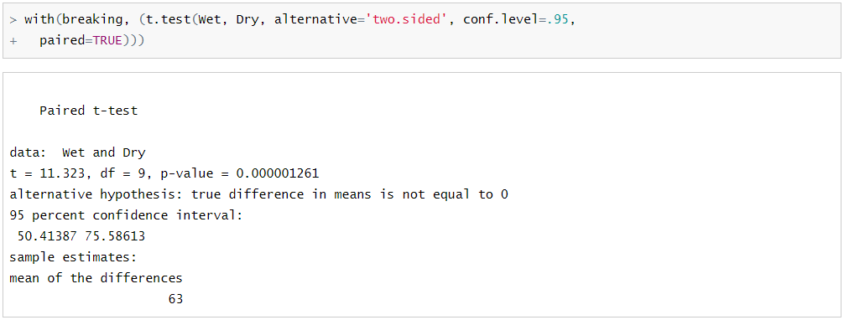
  - Conclusion
Because the p-value is small (i.e., less than 0.05) we reject the null hypothesis. There is enough evidence to support the claim that there is a difference between dry and wet pavements for this type of tire in terms of braking performance.

- Many states and localities now collect data on traffic stops regarding the race of the driver. The initial concern was that Black drivers were being stopped more often. With more data in hand, attention has turned to other issues. For example, data from 2533 traffic stops in Cincinnati report the race of the driver (Black, White, or Other) and whether the traffic stop resulted in a search of the vehicle. Is there evidence that race is a factor in vehicle searches?

 | Black | White | Other | Total
Not Searched | 787 | 594 | 27 | 1408
Searched | 813 | 293 | 19 | 1125
Total | 1600 | 887 | 46 | 2533

  - Explanatory variable and type
Race, Qualitative.
  - Response variable and type
Vehicle searches, Qualitative.
  - Null and alternative hypotheses
$$H_{0}:Race and vehicle searches are independent$$
$$H_{a}:Race and vehicle searches are dependent$$

  - Bar chart of proportions (use Excel)

  - Appropriate test result
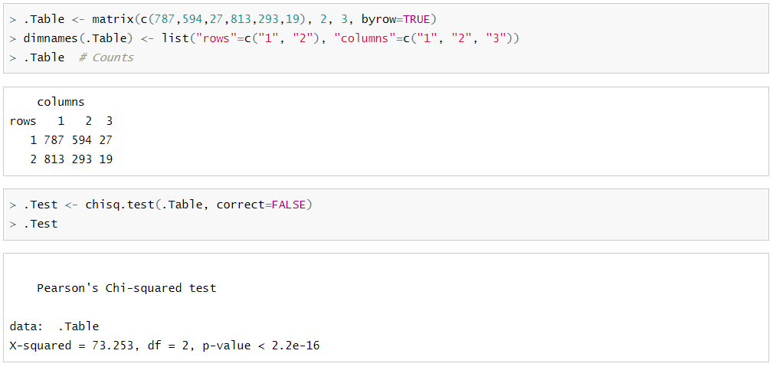
  - Conclusion
Because the p-value is small (i.e., less than 0.05) we reject the null hypothesis. There is enough evidence to support the claim that race and vehicle searches are dependent. In other words, race is a factor in vehicle searches.

- Does a person’s cholesterol level tend to change with age? This dataset was collected from 1406 adults aged 45 to 62.
  - Explanatory variable and type
Age, Quantitative
  - Response variable and type
Cholesterol level, Quantitative.
  - Screenshot of scatterplot + regression line
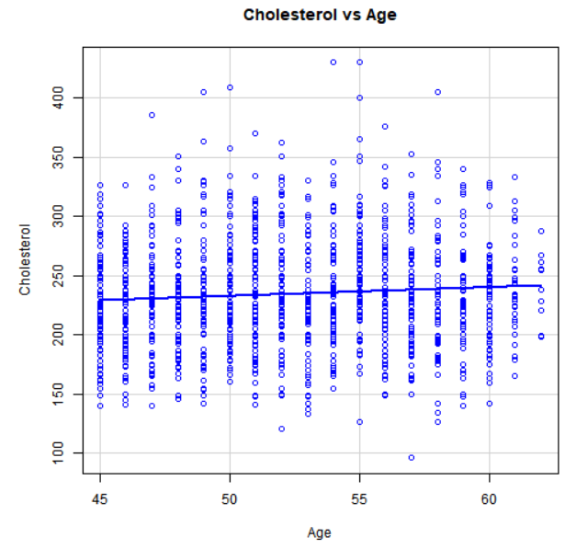
  - Correlation coefficient
0.0798
  - Regression model
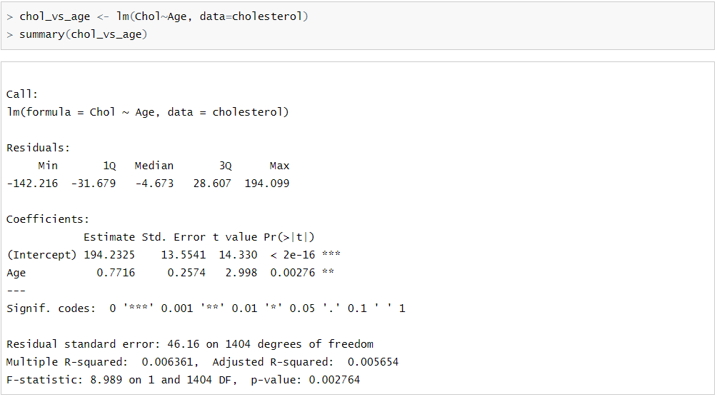
$$cholesterol=0.7716*Age+194.2325$$
  - Check assumptions
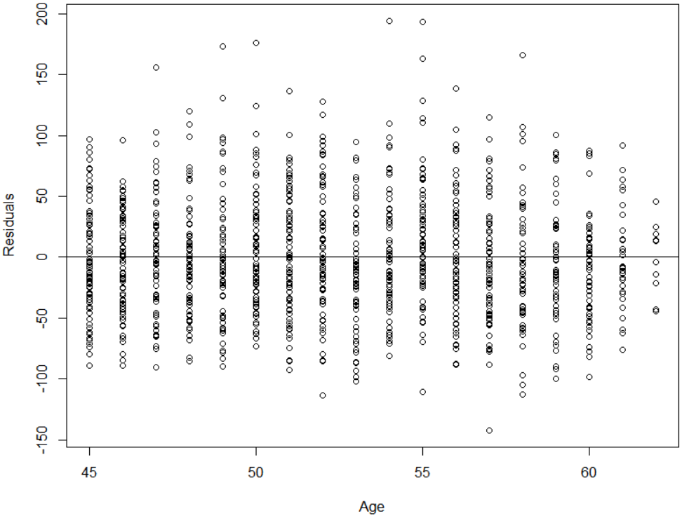
    - Linear
The residual plot does not exhibit any obvious pattern. Thus, this assumption is met.
    - Constant variation

The vertical spread of the points in the residual plot are roughly the same across the plot. Thus, this assumption is met.
    - Normality of residuals
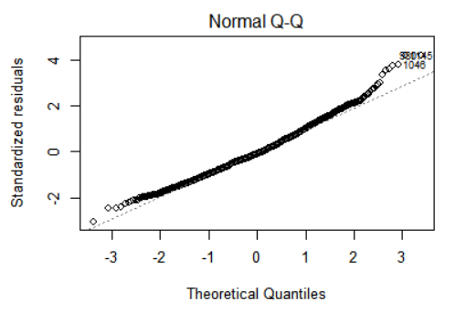
From the normal QQ plot we can check the normality assumption. Because most of the points fit into the straight line we can say that this assumption is met.
    - Independence
We have independent simple random samples.

  - Conclusion
Because the p-value is small (i.e., less than 0.05). There is enough evidence to support the claim that there is a linear relationship between Age and Cholesterol level. In other words, Cholesterol level tends to change with Age; even the older a person gets, the bigger will be his cholesterol level.

